Pokhara University

Level: Bachelor | Semester – Spring | Year : 2006
Programme: BE |  | Full Marks: 100
Course: Data Structure and Algorithms |  | Time : 3hrs.

Candidates are required to give their answers in their own words as far as practicable.
The figures in the margin indicate full marks.

Attempt all the questions.

 | - What is "Big oh" notation? What do you understand by efficiency of an algorithm?  - Write a module function to insert and delete an item in the queue in circular representation. You must state assumption clearly that are needed. | 5  10
 | - How can you identify a given linked list is circular or not? Write a procedure to insert an item at specified position.  - Write the steps required to delete a node form a Binary Search Tree (BST). Re-construct the resulting BST after deleting the node 6 from the following BST.  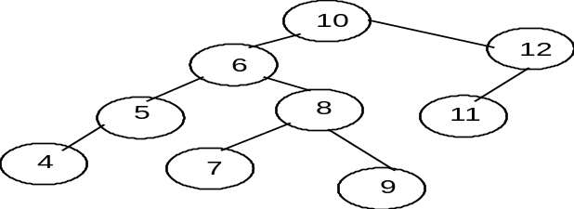 | 7  8
 | - Define heap. Show the creation of a heap having 8 random data and show heap sort process also.  - Write a recursive algorithm to find a factorial of a given number. | 10  5
 | - Write outline of divide and conquer sorting. Trace the quick sort algorithm for the following data: 2, 5, 1, 9, 3, 8, 7, 4, 6  - Write an algorithm to insert a node in tree for Binary Search. | 10  5
 | - Define AVL tree. Construct an AVL tree by inserting the following elements into an empty AVL tree. 33, 60, 5, 15, 25, 12, 45, 70, 35, 7  - Define Hashing. What are the collision resolving techniques in hashing? Explain about separate chaining and open addressing in detail. | 8  7
 | - What is minimum spanning tree? Find minimum spanning tree for the given graph using Prim's or Kruskal's algorithm.  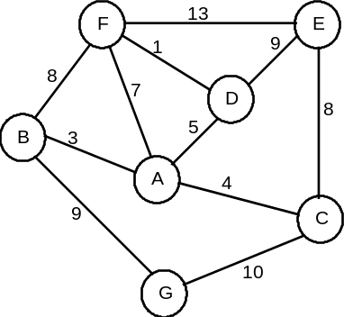  - Describe the terms strongly connected graph, degree of a node, loop and cycle in reference with graph as ADT. | 8  7
 | Write short notes on (Any Two):  - ADT and class  - Evaluation of postfix expression  - B-tree  - Binary search | 5×2

